Single-Phase Motors

**Single-Phase Induction Motors:**

A single phase induction motor is very similar to a 3-phase squirrel cage induction motor. It has (i) a squirrel-cage rotor identical to a 3-phase motor and (ii) a single-phase winding on the stator.

Unlike a 3-phase induction motor, a single-phase induction motor is not selfstarting but requires some starting means. The single-phase stator winding produces a magnetic field that pulsates in strength in a sinusoidal manner. The field polarity reverses after each half cycle but the field does not rotate. Consequently, the alternating flux cannot produce rotation in a stationary squirrel-cage rotor. However, if the rotor of a single-phase motor is rotated in one direction by some mechanical means, it will continue to run in the direction of rotation. As a matter of fact, the rotor quickly accelerates until it reaches a speed slightly below the synchronous speed. Once the motor is running at this speed, it will continue to rotate even though single-phase current is flowing through the stator winding. This method of starting is generally not convenient for large motors. Nor can it be employed fur a motor located at some inaccessible spot.

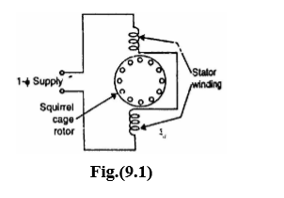

Fig. (9.1) shows single-phase induction motor having a squirrel cage rotor and a singlephase distributed stator winding. Such a motor inherently docs not develop any starting torque and, therefore, will not start to rotate if the stator winding is connected to single-phase a.c. supply. However, if the rotor is started by auxiliary means, the motor will quickly attain me final speed. This strange behaviour of single-phase induction motor can be explained on the basis of double-field revolving theory.

**Double-Field Revolving Theory:**

The double-field revolving theory is proposed to explain this dilemma of no torque at start and yet torque once rotated. This theory is based on the fact that an alternating sinusoidal flux (φ = φm cos ωt) can be represented by two revolving fluxes, each equal to one-half of the maximum value of alternating flux (i.e., φm/2) and each rotating at synchronous speed (Ns = 120 f/P, ω = 2πf) in opposite directions.

The above statement will now be proved. The instantaneous value of flux due to the stator current of a single-phase induction motor is given by; tcosm ωφ=φ Consider two rotating magnetic fluxes φ1 and φ2 each of magnitude φm/2 and rotating in opposite directions with angular velocity ω [See Fig. (9.2)]. Let the two fluxes start rotating from OX axis at

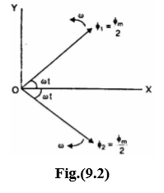 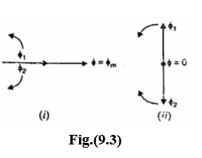

t = 0. After time t seconds, the angle through which the flux vectors have rotated is at. Resolving the flux vectors along-X-axis and Y-axis, we have,

Total X-component t costcos 2 tcos 2 m mm ω φ=ω φ +ω φ =

Total Y-component 0 tsin 2 tsin 2 mm = ω φ −ω φ = Resultant flux, ( ) t cos0tcos m 22 m ω φ=+ωφ=φ Thus the resultant flux vector is φ = φm cos ωt along X-axis. Therefore, an alternating field can be replaced by two relating fields of half its amplitude rotating in opposite directions at synchronous speed. Note that the resultant vector of two revolving flux vectors is a stationary vector that oscillates in length with time along X-axis. When the rotating flux vectors are in phase [See Fig. (9.3 (i))], the resultant vector is φ = φm; when out of phase by 180° [See Fig. (9.3 (ii))], the resultant vector φ = 0.

Let us explain the operation of single-phase induction motor by double-field revolving theory.

**1)Rotor at standstill:**

Consider the case that the rotor is stationary and the stator winding is connected to a single-phase supply. The alternating flux produced by the stator winding can be presented as the sum of two rotating fluxes φ1 and φ2, each equal to one half of the maximum value of alternating flux and each rotating at synchronous speed (Ns = 120 f/P) in opposite directions as shown in Fig. (9.4 (i)). Let the flux φ1 rotate in anti clockwise direction and flux φ2 in clockwise direction. The flux φ1 will result in the production of torque T1 in the anti clockwise direction and flux φ2 will result in the production of torque T2 In the clockwise direction. At standstill, these two torques are equal andopposite andthe net torque developed is zero. Therefore, single-phase induction motor is not self-starting. This fact is illustrated in Fig. (9.4 (ii)).

Note that each rotating field tends to drive the rotor in the direction in which the field rotates. Thus the point of zero slip for one field corresponds to 200% slip for the other as explained later. The value of 100% slip (standstill condition) is the same for both the fields.

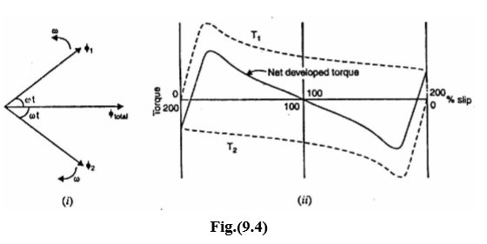

**2)Rotor running:**

Now assume that the rotor is started by spinning the rotor or by using auxiliary circuit, in say clockwise direction. The flux rotating in the clockwise direction is the forward rotating flux (φf) and that in the other direction is the backward rotating flux (φb). The slip w.r.t. the forward flux will be

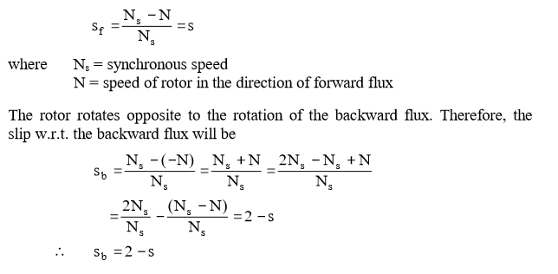

Thus fur forward rotating flux, slip is s (less than unity) and for backward rotating flux, the slip is 2 − s (greater than unity). Since for usual rotor resistance/reactance ratios, the torques at slips of less than unity arc greater than those at slips of more than unity, the resultant torque will be in the direction of the rotation of the forward flux. Thus if the motor is once started, it will develop net torque in the direction in which it has been started and will function as a motor**.**

Fig. (9.5) shows the rotor circuits for the forward and backward rotating fluxes. Note that r2 = R2/2, where R2 is the standstill rotor resistance i.e., r2 is equal to half the standstill rotor resistance. Similarly, x2 = X2/2 where X2 is the standstill rotor reactance. At standstill, s = 1 so that impedances of the two circuits are equal. Therefore, rotor currents are equal i.e., I2f = I2b. However, when the rotor rotates, the impedances of the two rotor circuits are unequal and the rotor current I2b is higher (and also at a lower power factor) than the rotor current I2f. Their m.m.f.s, which oppose the stator m.m.f.s, will result in a reduction of the backward rotating flux. Consequently, as speed increases, the forward flux increases, increasing the driving torque while the backward flux decreases, reducing the opposing torque. The motor-quickly accelerates to the final speed.

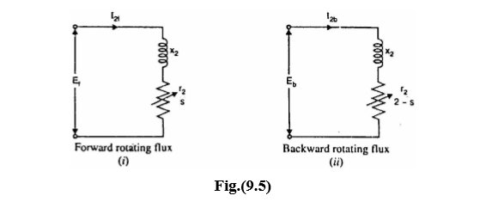

**Making Single-Phase Induction Motor Self-Starting**:

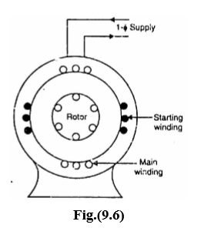The single-phase induction motor is not selfstarting and it is undesirable to resort to mechanical spinning of the shaft or pulling a belt to start it. To make a single-phase induction motor self-starting, we should somehow produce a revolving stator magnetic field. This may be achieved by converting a single-phase supply into two-phase supply through the use of an additional winding. When the motor attains sufficient speed, the starting means (i.e., additional winding) may be removed depending upon the type of the motor. As a matter of fact, single-phase induction motors are classified and named according to the method employed to make them self-starting.

1. Split-phase motors-started by two phase motor action through the use of an auxiliary or starting winding.
2. Capacitor motors-started by two-phase motor action through the use of an auxiliary winding and a capacitor.

(iii) Shaded-pole motors-started by the motion of the magnetic field produced by means of a shading coil around a portion of the pole structure.

**Rotating Magnetic Field From 2-Phase Supply:**

As with a 3-phase supply, a 2-phase balanced supply also produces a rotating magnetic field of constant magnitude. With the exception of the shaded-pole motor, all single-phase induction motors are started as 2-phase machine. Once so started, the motor will continue to run on single-phase supply.

Let us see how 2-phase supply produces a rotating magnetic field of constant magnitude. Fig. (9.10 (i)) shows 2-pole, 2-phase winding. The phases X and Y are energized from a two-phase source and currents in these phases arc indicated as Ix and Iy [See Fig. (9.10 (ii))]. Referring to Fig. (9.10 (ii)), the fluxes produced by these currents arc given by**.**

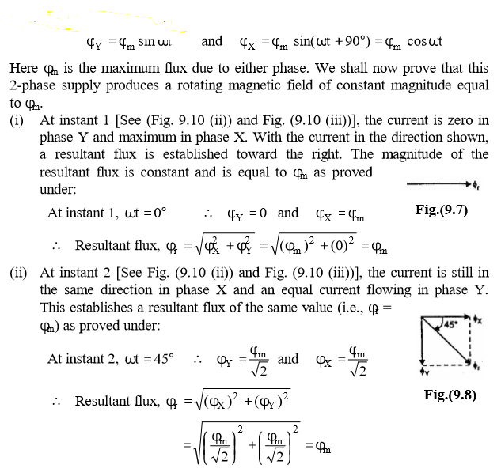

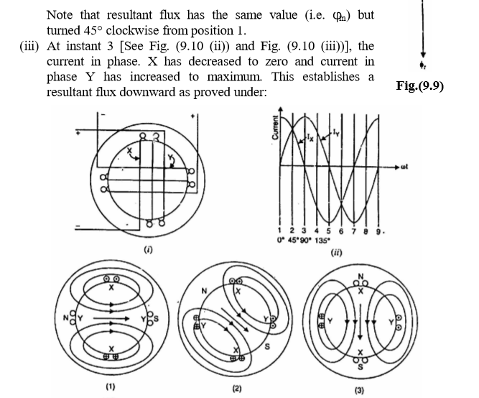

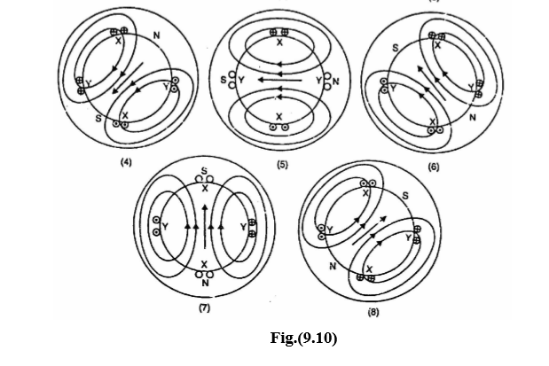

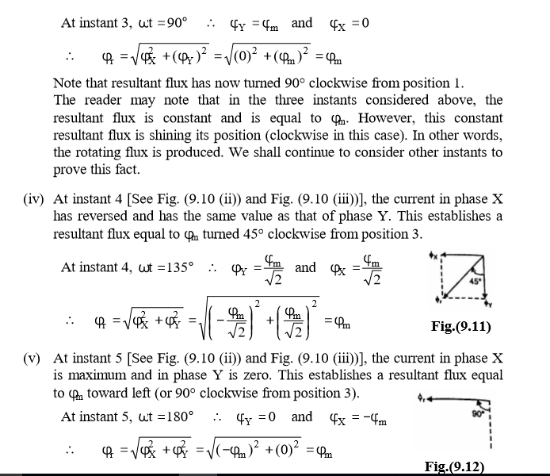

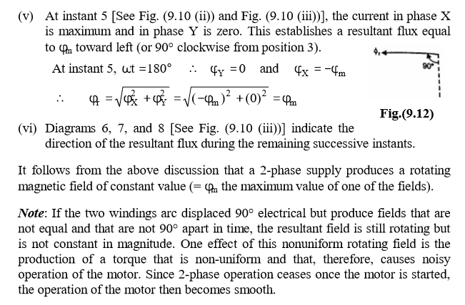

**Shaded-Pole Motor:** The shaded-pole motor is very popular for ratings below 0.05 H.P. (~ 40 W) because of its extremely simple construction. It has salient poles on the stator excited by single-phase supply and a squirrelcage rotor as shown in Fig. (9.16). A portion of each pole is surrounded by a short-circuited turn of copper strip called shading coil. 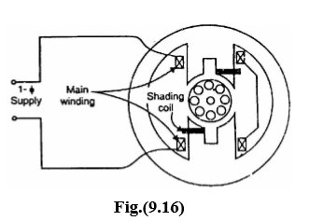

**Operation:**

The operation of the motor can be understood by referring to Fig. (9.17) which shows one pole of the motor with a shading coil.

(i) During the portion OA of the alternating-current cycle [See Fig. (9.17)], the flux begins to increase and an e.m.f. is induced in the shading coil. The resulting current in the shading coil will be in such a direction (Lenz’s law) so as to oppose the change in flux. Thus the flux in the shaded portion of the pole is weakened while that in the unshaded portion is strengthened as shown in Fig. (9.17 (ii)).

(ii) During the portion AB of the alternating-current cycle, the flux has reached almost maximum value and is not changing. Consequently, the flux distribution across the pole is uniform [See Fig. (9.17 (iii))] since no current is flowing in the shading coil. As the flux decreases (portion BC of the alternating current cycle), current is induced in the shading coil so as to oppose the decrease in current. Thus the flux in the shaded portion of the pole is strengthened while that in the unshaded portion is weakened as shown in Fig. (9.17(iv))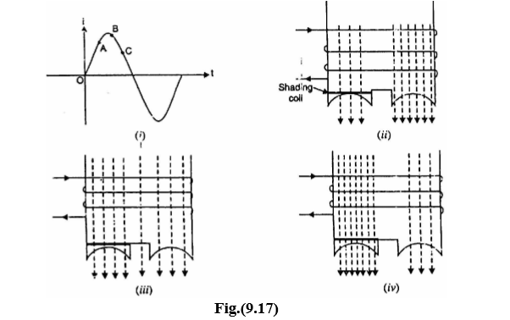

(iii) The effect of the shading coil is to cause the field flux to shift across the pole face from the unshaded to the shaded portion. This shifting flux is like a rotating weak field moving in the direction from unshaded portion to the shaded portion of the pole.

1. The rotor is of the squirrel-cage type and is under the influence of this moving field. Consequently, a small starting torque is developed. As soon as this torque starts to revolve the rotor, additional torque is produced by single-phase induction-motor action. The motor accelerates to a speed slightly below the synchronous speed and runs as a single-phase induction motor.

**Characteristics**:

(i) The salient features of this motor are extremely simple construction and absence of centrifugal switch. (ii) Since starting torque, efficiency and power factor are very low, these motors are only suitable for low power applications e.g., to drive: (a) small fans (6) toys (c) hair driers (d) desk fans etc.

The power rating of such motors is upto about 30 W.